FRONT


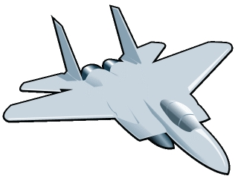
Fly back in time in
a

Book

January is
Aviation Month
@
Jones Elementary

Soar to new reading heights
in a

Book

January is Aviation Month
@
Jones Elementary

Soar around the world in a

Book

January is Aviation Month
@
Jones Elementary

Pilot
grand adventures in a

Book

January is Aviation Month
@
Jones Elementary

Have a high-flying adventure in a

Book

January is Aviation Month
@
Jones Elementary

Name
123 Main St.
Clemson, SC
555-0180
“Slogan or quotation about books or reading”
Name
123 Main St.
Clemson, SC
555-0180
“Slogan or quotation about books or reading”
Name
123 Main St.
Clemson, SC
555-0180
“Slogan or quotation about books or reading”
Name
123 Main St.
Clemson, SC
555-0180
“Slogan or quotation about books or reading”
Name
123 Main St.
Clemson, SC
555-0180
“Slogan or quotation about books or reading”
BACK
┐ ┬ ┬ ┬ ┬ ┌
┘ ┴ ┴ ┴ ┴ └

